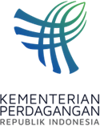
PRESS RELEASE
Public Relations Bureau
Bldg. I Fl. 2, Jl. M.I. Ridwan Rais No. 5, Jakarta 10110 Phone: 021-3860371/Fax: 021-3508711
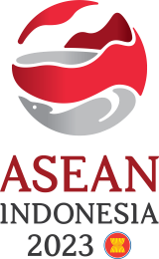
www.kemendag.go.id
The 19th AEM-EU Consultation Meeting, Trade Minister Zulkifli Hasan: ASEAN Region with the Greatest Economic Opportunities

Semarang, 20August 2023 — The Indonesian Minister of Trade, Zulkifli Hasan, said that the European Union views ASEAN as the region with the greatest economic opportunities in the world. This is reflected in the presentation that emerged at the 19th Consultation Meeting of ASEAN Economic Ministers (AEM) with the European Union, or the 19th AEM-EU Consultation today, Sunday (20/8) in Semarang, Central Java.

“The European Union's business world view is that ASEAN is the region with the greatest economic opportunities. Most of the survey results show that the place with investment, economic growth, and trade whose prospect is most profitable for the European Union is ASEAN," said Trade Minister Zulkifli Hasan.

The meeting was attended by ASEAN Trade Ministers and ASEAN Secretary General Kao Kim Hourn. Also present were representative of the European Commission Christophe Kiener and Secretary and Member of the Executive Board of the EU-ASEAN Business Council (EU-ABC) GustaafReerink.

"I also ask that EU-ABC provide proposed solutions to the challenges currently being faced by ASEAN to strengthen cooperation with the European Union, as well as support sustainable and inclusive economic growth in ASEAN," said Trade Minister Zulkifli Hasan when opening the consultation meeting.

The first session started with the Meeting of the ASEAN Economic Ministers with the EU—ABC. The meeting discussed challenges whose solutions must be sought together, including the impact of climate change on economic development and supply chain efficiency. Also discussed were the results of the ASEAN-EU Business Sentiment survey, particularly regarding digitalization to support small and medium enterprises (SMEs).

“Trade and investment between ASEAN and the European Union have improved after the pandemic. The European Union has once again become the second source of foreign investment for ASEAN in the last ten years. The European Union is consistently the third largest trading partner for ASEAN. This illustrates the strong trade relations between ASEAN and the European Union,” said GustaafReerink.

In this meeting, ASEAN and the European Union both recorded progress on the implementation of the ASEAN-EU trade and investment work program for 2022-2023, including cooperation between business actors. ASEAN and the European Union also ratified the ASEAN-EU trade and investment work program for 2024-2025, which includes EU support in the field of capacity building.

Semarang is hosting the series of the 55th AEM Meeting and Related Meetings on 17-22 August 2023. Starting with the Preparatory Meeting of Senior Economic Officials or Prep-SEOM for two days on Thursday and Friday, 17-18 August 2023, the series continues with a series of ASEAN Economic Ministerial Meetings for four days from Saturday to Tuesday, 19-22 August 2023.

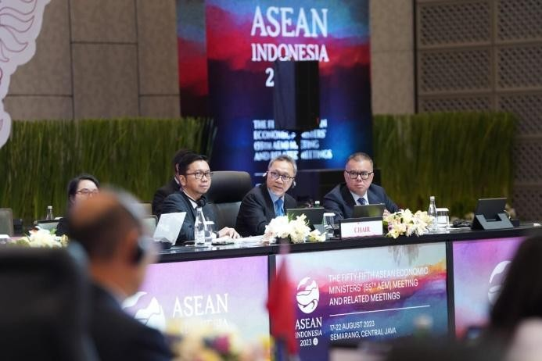
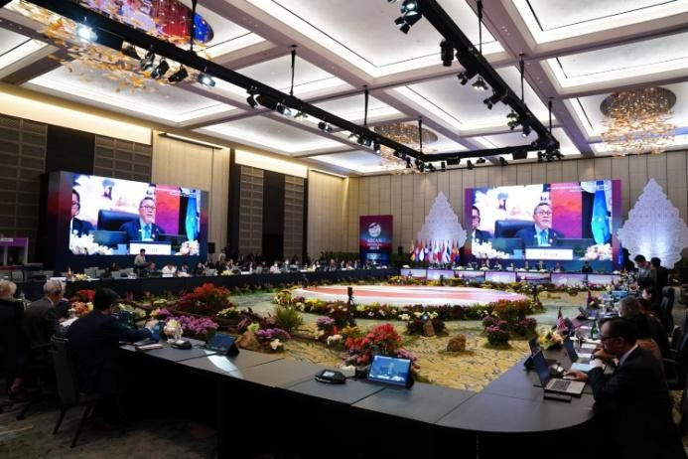
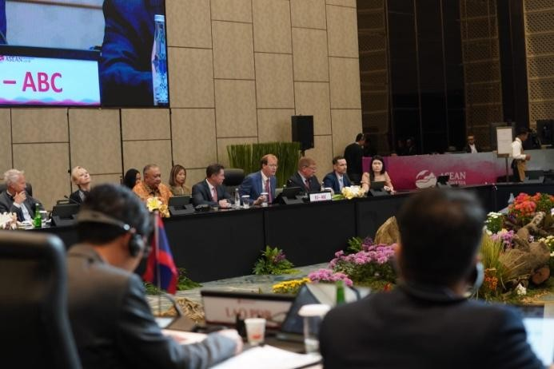
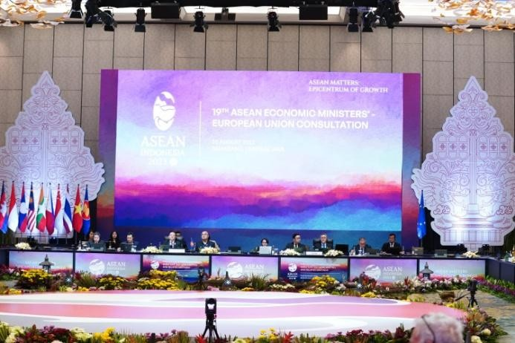

--end--

For further information please contact:  Ani Mulyati  Head of Public Relations Bureau Ministry of Trade  Email: pusathumas@kemendag.go.id | Dina Kurniasari  Director of ASEAN Negotiations  Directorate General of International Trade Negotiations Ministry of Trade  Email: asean@kemendag.go.id

